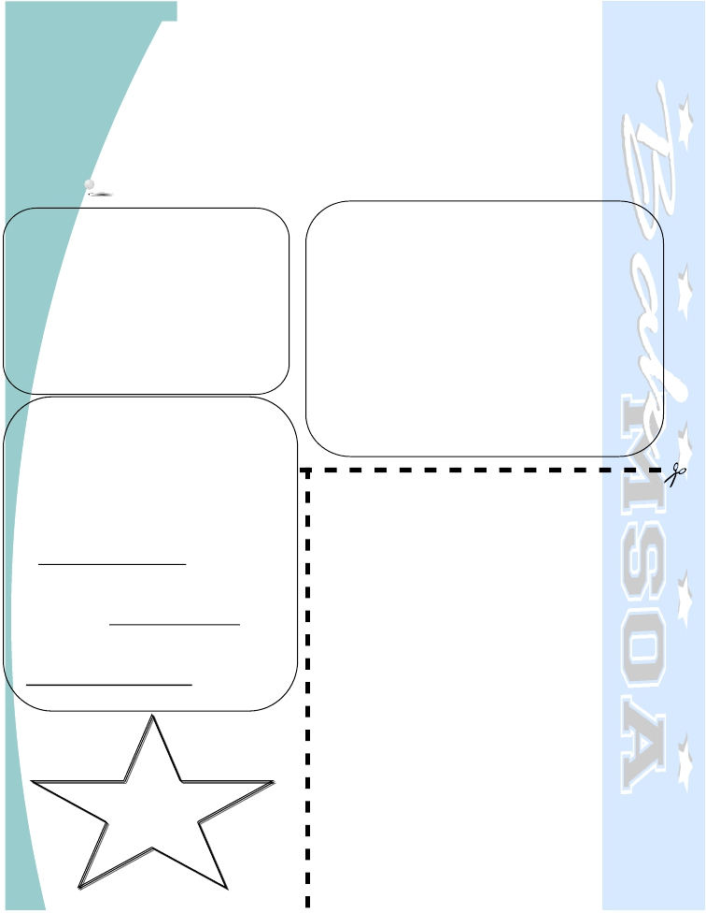
Proudly presented by the Bak MSOA PTO

Food Trucks Invade Starfest 2020

Our annual Starfest is your only opportunity to attend performances and exhibitions in every art area at Bak MSOA all in one magical evening! It’s a special night with a rotating schedule of events. Starfest is the PTO’s annual fundraiser, and the proceeds fund so many of our important programs, grants and technology upgrades. Starfest quickly sells out! (After April 9th, tickets will be available to new students and their families.) Food can be purchased separately from a variety of food trucks. Dinner is NOT included in the ticket price.

Date: Friday, April 17, 2020

Time: 5:30 PM to 9:00 PM
Location: Bak Middle School of the Arts
1725 Echo Lake Drive, WPB, FL 33407

Please arrive on time. We have a full
rotating schedule of events which you will
receive upon your arrival.
Please do not park on our neighbors’ grass!

For event and ticket information contact
Alison Kinney at bakmsoapto@gmail.com

For volunteer info. contact Maya Kirby at
bakvolunteers@gmail.com
TICKET PRICES: Include ONLY admission to each

Starfest
2020

performance. Children 4 and under are free. Dinner can be purchased from the food trucks.

TICKETS ARE $30 EACH for cash or check.
$35 ONLINE for credit card (www.bakmsoapto.com)
If we sell all 750 tickets, this will be our only
fundraiser for the year!

You can pre-order tickets through April 2nd.
Tickets will then be sold April 6th – April 8th in the
Cafeteria during lunches. Pre-ordered tickets can be
picked up during this time.

Please make checks payable to: Bak MSOA PTO

TICKETS SELL OUT! BUY THEM EARLY! NO SALES AT THE DOOR!
[ ] Yes, I would like __________ tickets to STARFEST
for a total of $ __________.
***No Refunds***
Family/Student Name
_____________________________

(PLEASE PRINT)

Student’s 7th hour teacher
_________________________________

Student’s 8th hour teacher
_________________________________
Please have student drop off the order form & payment in an envelope marked PTO STARFEST in the PTO box at Student Services.
Thank you!

